March 2024 Paper B recall/- Stats questions were new but not all newguys

PLZ READ
RECALLS
SPMM
PSYCHMENTOR notes and MCQs
Every single word of vidoes

- There was a question of suss criteria for causation. Micro, 2 macro options, end stage
- Like PTSD graph, clozapine consort diagram were new
- 2 mediator questions were from spmm mock 14 2024 with (new) different options
- There was just one percentage asked in question I guess
- Life time prevalence of suicide in EUPD . A) 10% B)20%
- Choosing the correct statistical test was asked about 3-4 times. Yes was very confusing 🤔
- Mild depression in 12 years old, family therapy,cat, DBT,digital cbt
- Repeated topics definitely . but I felt equal proportion of repeats and new questions. Some were tricky .
- Sensitivity many questions about qualitative study
- Yea qualitative question where they have compared study with other sources for analysis??? triangulation?
- Drug from class B it is ketamine just confirmed. Other options were a . Methamphetamine
- EMI 1- Defense mechanisms. i A man who is planning to cheat on his wife , he believes she is un faithful 2- two friends who are both drinking one of the two is dependent and the other is not. The one who is alcohol dependent tells the other that he is drinking too much, which makes him convinced and he try and look for advice. 3- A woman who nourishes her daughter, but deeply she despises her
4- a man who was told a news and he went and read about it to understand ( I don’t remember the scenario exactly but looked like intellectualization )
- EMI About the risk factors of 1- Conduct 2- ADHD 3- Anorexia nervosa
The options were 1- high social status 2- temperament 3- high enmeshment in the family
4- maternal smoking
- About 4-5 questions about the methodology of qualitative research
- EMI about data collection 1- block randomization 2- stratification 3- simple random sampling
- A question about internal consistency 1- inter rater reliability 2- split half
- there was a ?? mistake in one of the stat question options (C - was something like in a skewed daha median is left to median)?Mode option was right there
- ID child with behaviour issues high risk of????? Bipolar, schizophrenia,
- Risk of arson is high in,,, ID, substance use,
- Child with ADHD and tics already on methylphenidate with liver disease tics worsen mother wants drug with less sedation?. Patient had liver disease so atomoxetine would be the right answer . Options were a. Clonidine b. Guanfacine C. Risperidone d. Atomoxetine
- 10 weeks pregnant on methadone 80mg wants to stop methadone, what is next step??? A. Continue same dose (do nothing ) b.Increase c. Reduce dose gradually d. taper in 2 weeks , e. switch to buprenorphine. , because she was in the 10th week of pregnancy, withdrawal will increase the risk of miscarriage
- Grunting, clearing throat, grimacing, ticks over a year, tourette? Chronic motor?
- Drug contraindicated in epilepsy???? Just remembered one option lithium. Epilepsy, Qtc prolongation
- For which antidepressants ECT voltage should be decreased. Lofepramine,maclobamide, venlafaxine
- Long EMI About aphasia . The sub types 1- global 2- broca 3- wernicke’s 4. Conductive
- Pharmacological management off panic disorder and the patient did not respond to first line.
- Ect is firstline according to nice guidelines, severe mania, treatment resistant depression,catatonia.
- What is the difference between ECT and rTMS. a. ECT had lower side effects b. ECT needs more frequent sessions c. ECT works in a specific area of the brain d.ECT is better than rTMS for treatment resistant depression
- Medication of choice in body dysmorphic disorder
- There was only one question where you have to draw a 2*2 table And asked to calculate a. LR positive b. Sensitivity c. NPV
- A question about CONSORT graph , how to calculate the prevalence of those who completed the study and those who failed to. How many who started clozapine titration initially?
- Alzheimer's with depressive symptoms, CBT, galantamine, donepzil, quietiapine, olanzapine, risperidone
- A question about the best kind of study to validate MMSE in comparison to post mortum Alzheimer testing a- cross sectional b. cohort
- Suicide rate in borderline personality disorder
- One question about a scale of depression, the scale included all the affective symptoms but missed the somatic symptoms a- face validity b- ⁠criterion c- ⁠content d. Construct (content validity is lacking)
- Alzheimer's with behaviour symptoms on risperidone 1mg but not improving next step
- Lithium contraindicated in, Addison's,myasthenia gravis, epilepsy, qt prolongation, Graves
- 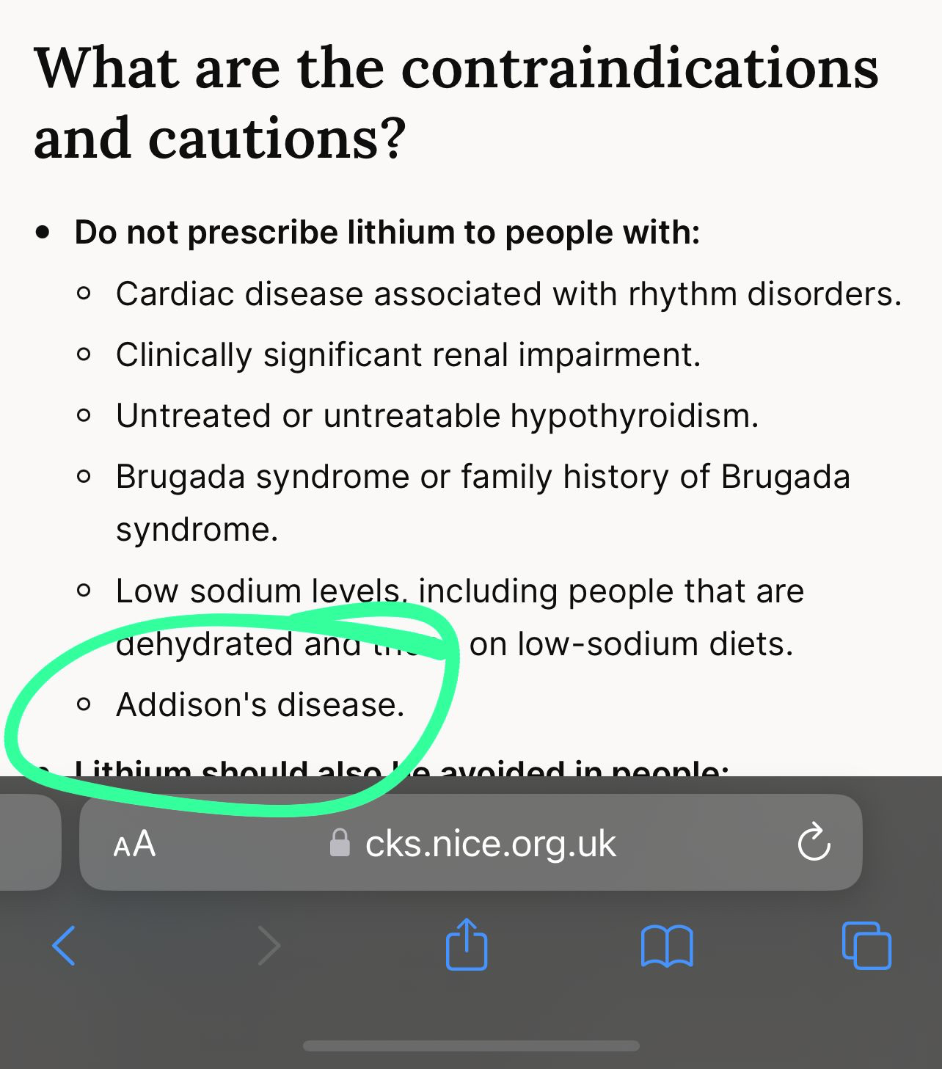There is of hyperthyroidism initially but rare, Child with mild ID, feeding difficulty and cardiac anomaly??, Child with high pitch cry?, Child with gaze avoidance and hypertelorism?
- Child with mild depression? Digital CBT, cat, DBT, family therapy,
- jocular speech, gaze aversion which disease
- A graph with PTSD over a 85day period, with 5 groups, I believe late onset, chronic, resilient, remission, partial remission? I struggled to understand that one. It was desister it asked which graph represents late onset PTSD and which gives worse prognosis I guess
- Cathionine gives false positive test with a. pseudoephedrine,b. naproxen
- Patient who had hemoragic stroke and developed depression. What antidepressant should not be used
- Also patient with hemoragic stroke developed involuntary flinging movement in left arm and leg. A. Akathesia b. Serotonin syndrome
- Genomic imprinting in which disease - downs, fragile x, lesch nyhan, and two other options
- There was one question like cathionine is a a. psychedelic b. Stimulant c. Depressant
- Drug with gaba A agonists and nmda antagonists effect. A. Alcohol b. Ketamine
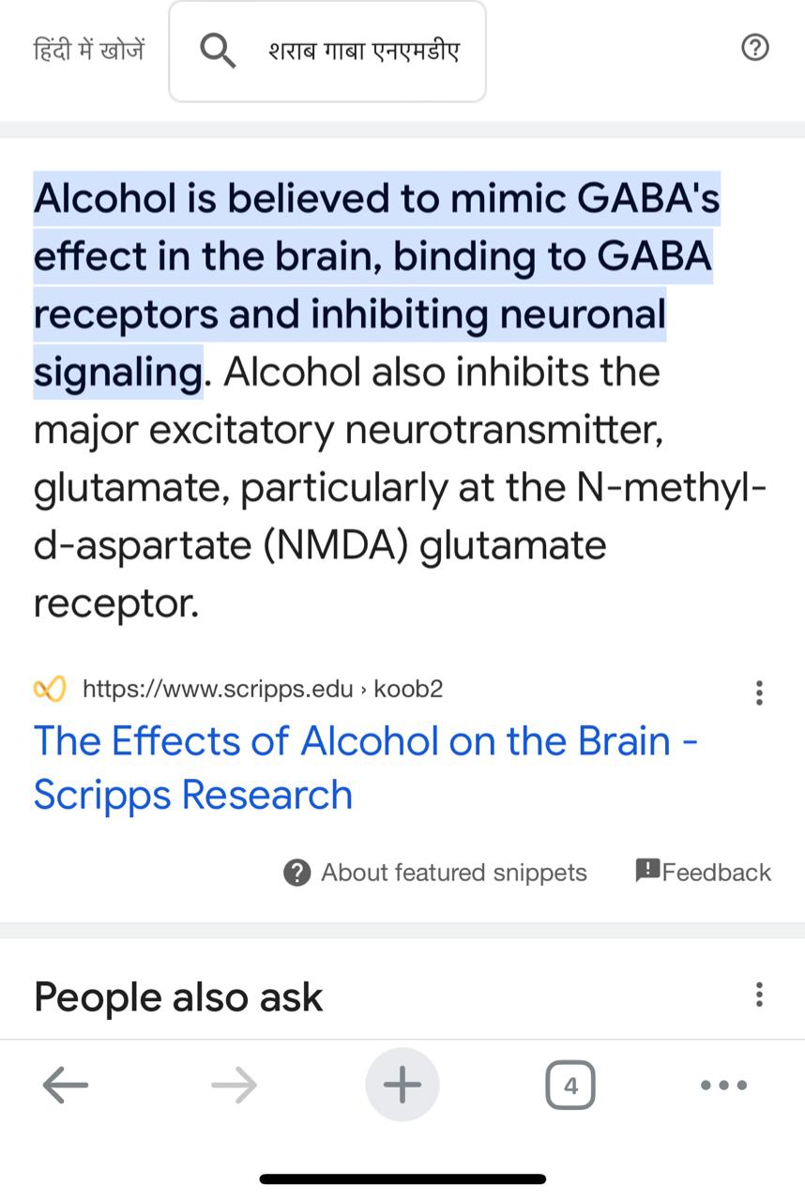
- PT with bird flapping tremors????
- Commonest cause of young onset dementia in Uk - Alzheimer’s, Huntington, fronto temporal,
- Parkinson with behaviour issues what should be done first??? A. donepezil b. Quetiapune
- Sexual reoffending dynamic risk factor?Antisocial and paraphilia was there
- as susser's criteria are a. proximity b. time lapse c. association
- Treatment of bulemia nervosa first line. A. Self guided help
- first line for 16 year old with ocd a.sertraline b. fluvoxamine c. something else
- Macroscopic and macroscopic proximity
- the emi with all the ssris was so confusing
- Son brought his 75 years old father which feature suggests Alzheimer's, a. Short term memory loss,b. son paying bills of his father. i chose short term memory loss as losing functionality is a late symptom?
- Killed his 18 months old child that she is protecting him from evil something???. Diminished responsibility b. Criminal responsibility c. Insanity
when it's murder it would be diminished responsibility and she'd likely get charged with manslaughter
- What about men's rea and actus rea
- 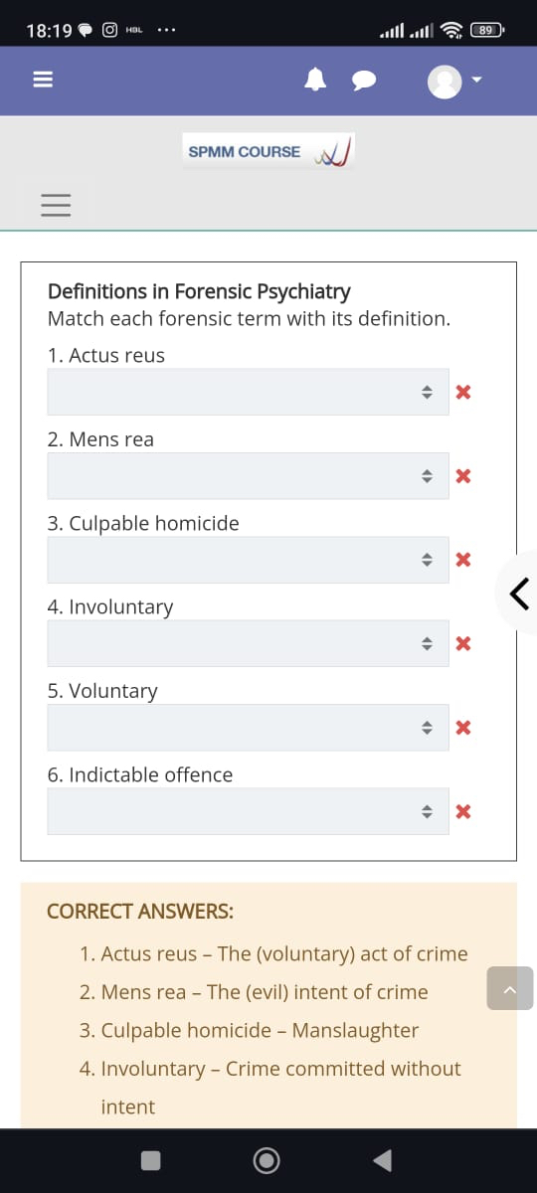This was question except today answer given as question

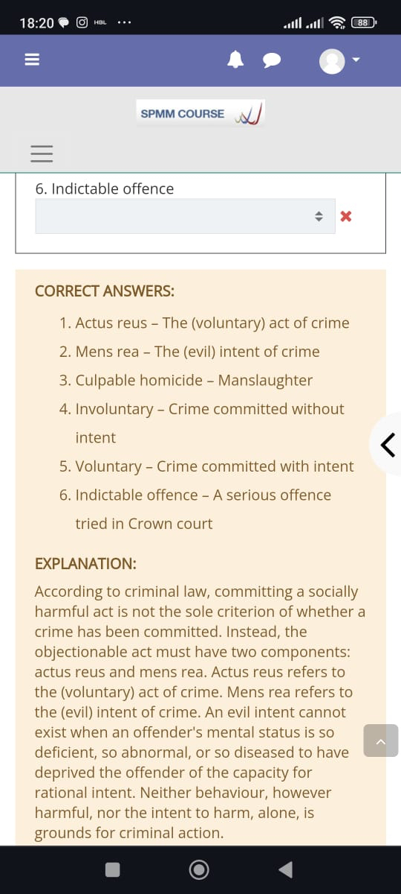these were the questions
- Characteristic of schizoid personality
- Difficulty in feeding,cardiac abnormalities, . Which syndrome. A. Edward b. downs
- PT taking sertraline, procylidine, lithium develop hyperthermia, hyperflexia,BP fluctuations dx? A. Serotonin syndrome Brisk reflexes so serotonnin syndrome
- Spearman pearson choices
- Log transformation
- Had to tell what analysis will be performed when disease outcome with age is to be compared
- Intellectual disability with new behaviour issues takin off clothes not sleeping for 2 weeks a. Mania b. Bipolar 1
- A young child mild depressed . Option was watchful waiting for 6 wks something i chose cbt because watchful waiting is for 4weeks
- Panic disorder 2nd line treatment
- Also patient with hemoragic stroke developed involuntary flinging movement in left arm and leg. Hemibalismus?
- What was Ans that graph with altitude????That one was the same as one of the mocks, more opioids prescribed in the north
- phase 1 for 20 patients drug trials
- phase 3 for waiting for approval
- What about star D next step, Adding which drug. A. Bupropion
- Posmorten dx of Alzheimer x MMSE (best study) a. Cross sectional b. Retrospective cohort c. Prospective cohort .!but to study the accuracy of any test - cross sectional is the best however it was post mortem so I was confused
- Lifetime prevalence of suicide rate among EUPD
- 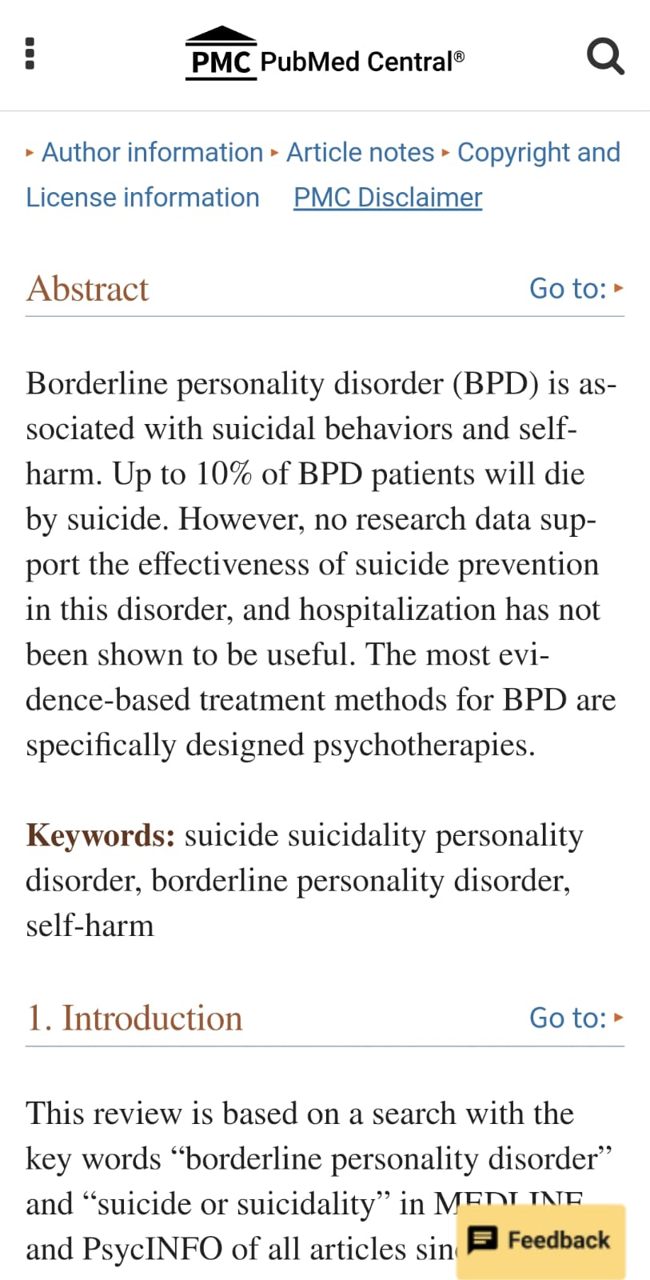Which of the following has an equal rate between males and females - GAD- ⁠unipolar depression - ⁠PTSD- ⁠Hypochondriasis
- The classification of Ganser syndrome in ICD11 - Dissociative - ⁠Factitious
- Couple of questions about dissociative disorders 🥲🥲There was one which was bodily distress disorder but the ICD-10 version of the name 😡
- Fague generalized symptoms, what is the ICD11 classification - body distress disorder - ⁠body integrity disorder
- There were who was looking for operation. Hypochondriasis?
- Body integrity dysphoria is where they essentially feel dysphoric about not having some abnormality/physical disability
- Aphasias I put transcortitial motor, sensorial and the thirds progressive aphasia
- A patient complaining of feeling fatigued , lack energy I dont remember the rest of the presentation But they were all vague physical symptoms. Neurasthenia?b. somatization c.GAD
The presentation looked like chronic fatigue syndrome to me because he mentioned feeling fatigue I think if it was GAD he would have mentioned free floating anxiety or something
- Anorexia I've put increased cortisol or high income countries , ADHD- maternal smoking, Family enmeshment or behavioral temperament was for conduct, arson- substance abuse or ID , bird flapping tremor -
- Low ceruloplasmin- Wilson
- Schizod personality question
- What did people put for the post intracerebral haemorrhage Antidepressant one. Sertraline b. Mirtazapine
- Question on secondary handicap. A. Valerie b Psychoanalyst c. Secondary handicap concept
- Homocysteine is risk factor of dementia
- Panic disorder what was second line. a. venlafaxine b. fluoxetine c. Buspirone
- what antidepressant increased suicide risk. A. Amitriptyline
- In ect decrease dose of which antidepressants a. Venlafaxine b. Mocobemide C. Lofepramine (TCA) d. paroxetine
- Antidepressant with least sexual dysfunction:- a. bupropion b.
- head injury in children:- a. Mood disorders b. c.
- And increased risk of suicide in a patient in hospital - head injury
- 3 questions about medication choice for children/Adolescent
- Hyperhomocystinemia, a. dementia? B. ASD c. Depression
- Medication for alcohol withdrawal with liver problems - lorazepam
- Another question was old age with cognitive impaired something and what test is used for premorbid intelligence options were mmse,moca, wisc, NART
- He didnt return my call so he must hate me
- Core criteria for Dementia with Lewy body a. Visual hallucinations b. Sensitivity to neuroleptics
- Imprinting- Fragile X b.Prader Willi
- ASD with avoiding gaze- Fragile X
- Team leader asks which drug is prefered X or Y. A. Survey - patient views b. Systematic review - evidence of efficacy c Case report - unknown SE
- There was a systematic review in one of those EMIs as wel
- Phases of research
- Full agonist causing paranoia .a. Meth
- A question in CAMHS about LD patient ( or autistic) who developed restlessness, lack of sleep and disinhibition for 2 weeks. What is the disgnosis according to ICD11 a.Bipolar 1 b. Psychosis c.
- I put 1 as the mean was the highest in 2nd PTSD graph
- Common mental disorder graph and past history of imprisonment
- Qualitative test (something that reduces bias)
- The characteristics of systematic errors ? Repeatable
- Fixed effect analysis-
- Method for Reducing social desirability bias. Options included triangulation, member checking and can’t remember
- Options were I2= 66% , p value < 0.001 1- mild heterogeneity, 2- moderate , 3- Substantive
- Method for Reducing social desirability bias. Options included triangulation, member checking and can’t remember. I've put reflexivity... i was between this and thematic analysis
- Susser one :- Proximity, microscopic, macroscopic, endstage
- Reducing confounder during analysis
- What does fixed effect analysis consider right ? - variability releated to error in the study
- One question about causality. Options internal validity, external validity, p value, specificity , ´
- Another one about a new test for depression. Gets psychological symptoms but not physical/organic
- What cox regression was used in one stem.
- Was the lady thinking about neuroanatomy intellectualising ?
- Schizophrenia and the general population right .I was between prospective and retroactive cohort
- There was also a question about why used log regression
- Binary data ( dependent and independent ) ?
- The other option was both dependent and independent binary but the independent looked like ordinal
- Test for Internal consistency. I've put test-retest reliability for one of the question. Don't remember headline b. Split half c.
- Donepezil I gave to the mixed dementia Vascular/Alzheimer
- Wing beating tremor?Wilsons and ceruloplasmin
- Genomic imprinting is the etiology of Fragile X, while error in genomic imprinting gives the result of Prader Willi and Angelman Syndrôme
- X and Y who didn’t answer something? Dichotomous?
- Standard deviation was 25 , sample size was 25 and mean was 100. They asked about the 95% confidence range.Yes SE will be 5 so 2SE for 95% CI which is 10 It was approx 90 to 110
- You had to calculate standand error from the standard deviation.YesI forgot that 95% equal 2 SD. So I subtracted 5 and added 5 . It should be 10
- I recalled a question about the cost .A man who goes for ECT , he is not working and the hospital is paying for his transport- Direct cost - ⁠indirect cost. I thought it is direct for thr hospital (transportation cost) and indirect for the patient (does not work) and the question was for him (the patient) so picked indirect
- Smoked something and felt relaxed. Cannabis . And the the plant based one with increased energy was cocaine
- false positive methadone screen a. cathionine b. paeudoephedrine c. Naproxen
- name of psychologist for some therapy :- In 1992 Valerie Sinason published the book ‘Mental Handicap and the Human Condition’
- The question was about the 2nd line for a patient who had OCD and depression, right? M- Fluvoxamine- ⁠fluoxetine
- There was a question about the type of data . Social deprivation is ordinal ?
- One of my ans was >75 years, having reduced risk of mental illness

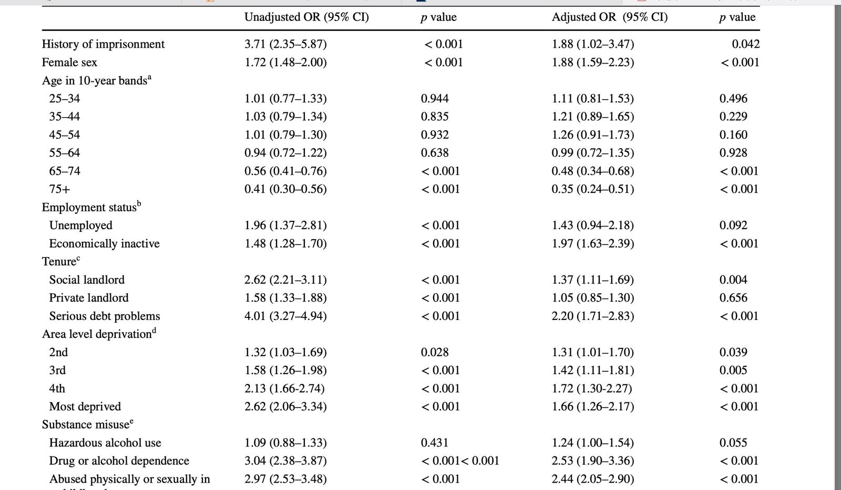
- What was about the sexual abuse?I think it was "results not get by chance"
- There was a question about physical about - Unlikely to be due to chance . Or unadjusted is 2.05
- I've answered confounders for one of them. About the OD reduction
- What about the one asking what explained the difference in adjusted and not adjusted for history of imprisonment
- Clozapine - sedation- motivation
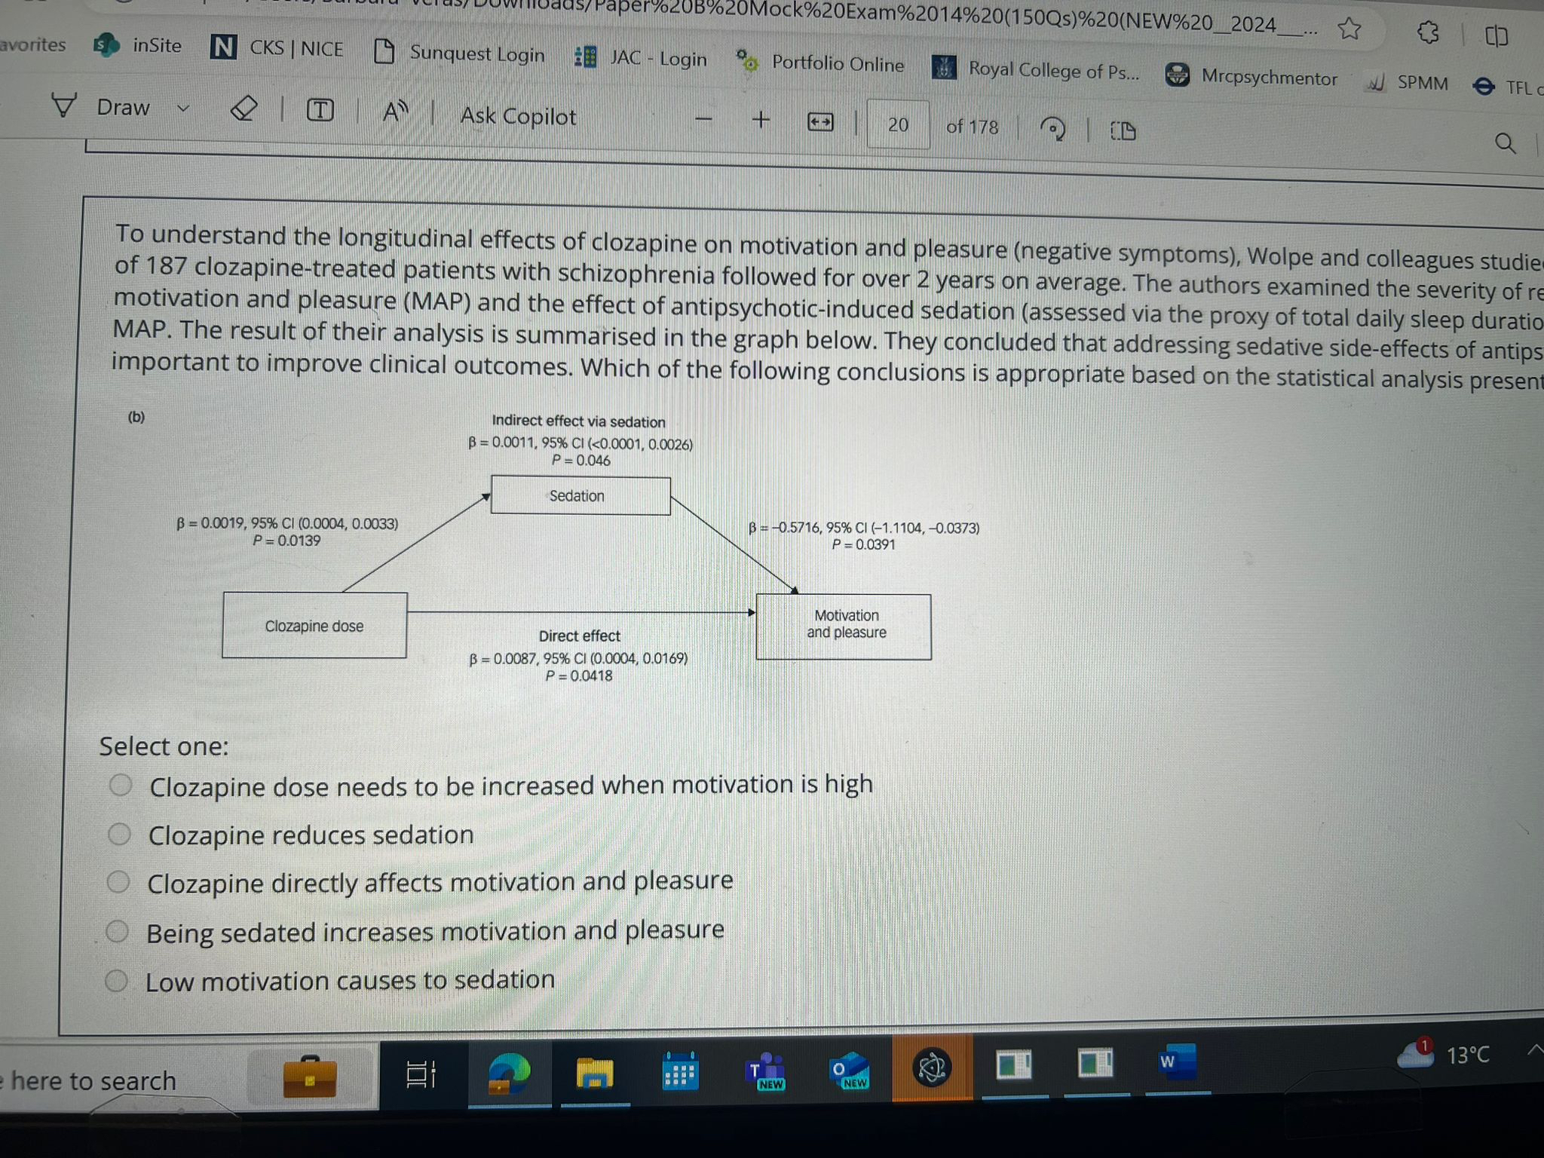
This was in the exam but with a different question
- 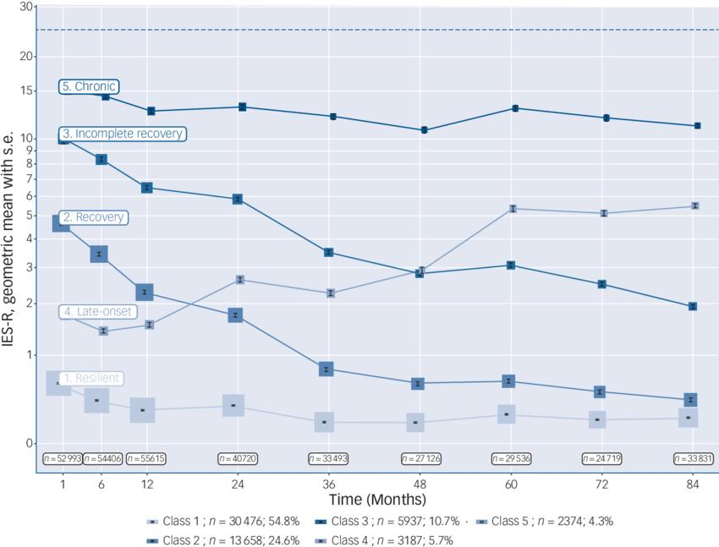
- I think it was sedation negatively affects motivation. 3 worst prognosis
- There was one that I had no idea which was the right one, there was. Kendall coefficient among the answers
- There was also one about relationship between BP and another continuous variable, adjusting for age, which test?
- 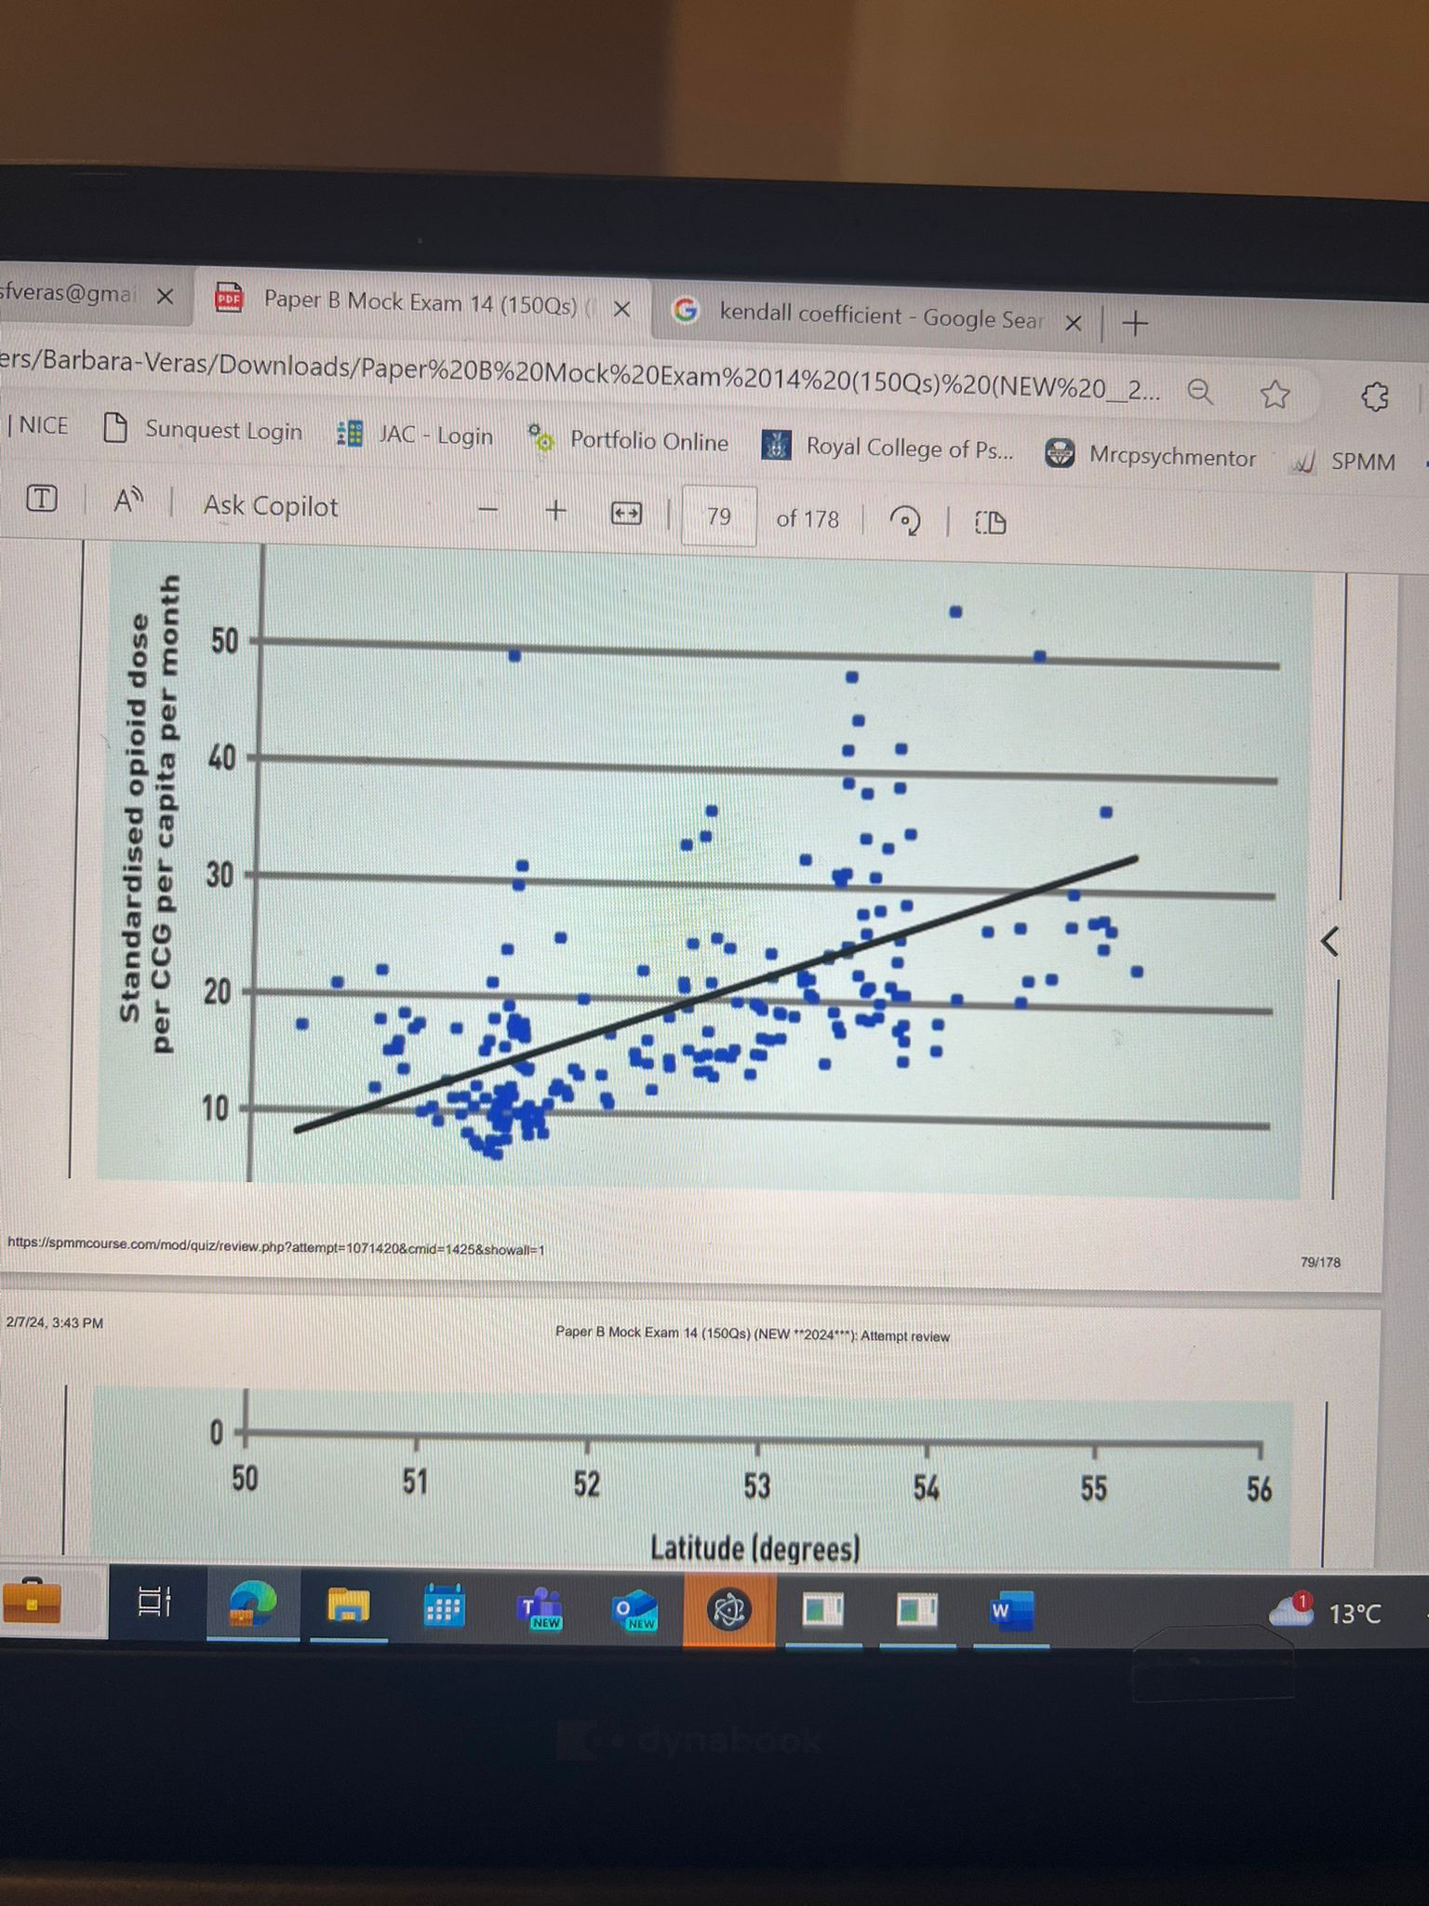
- There was another one about 1054 schizophrenic patients then divided into 3 groups (suicide was one of them) which test to estimate risk factors for suicide? I put Chi square but not sure at all. Yes it is chi square because it is binary data right ?
- 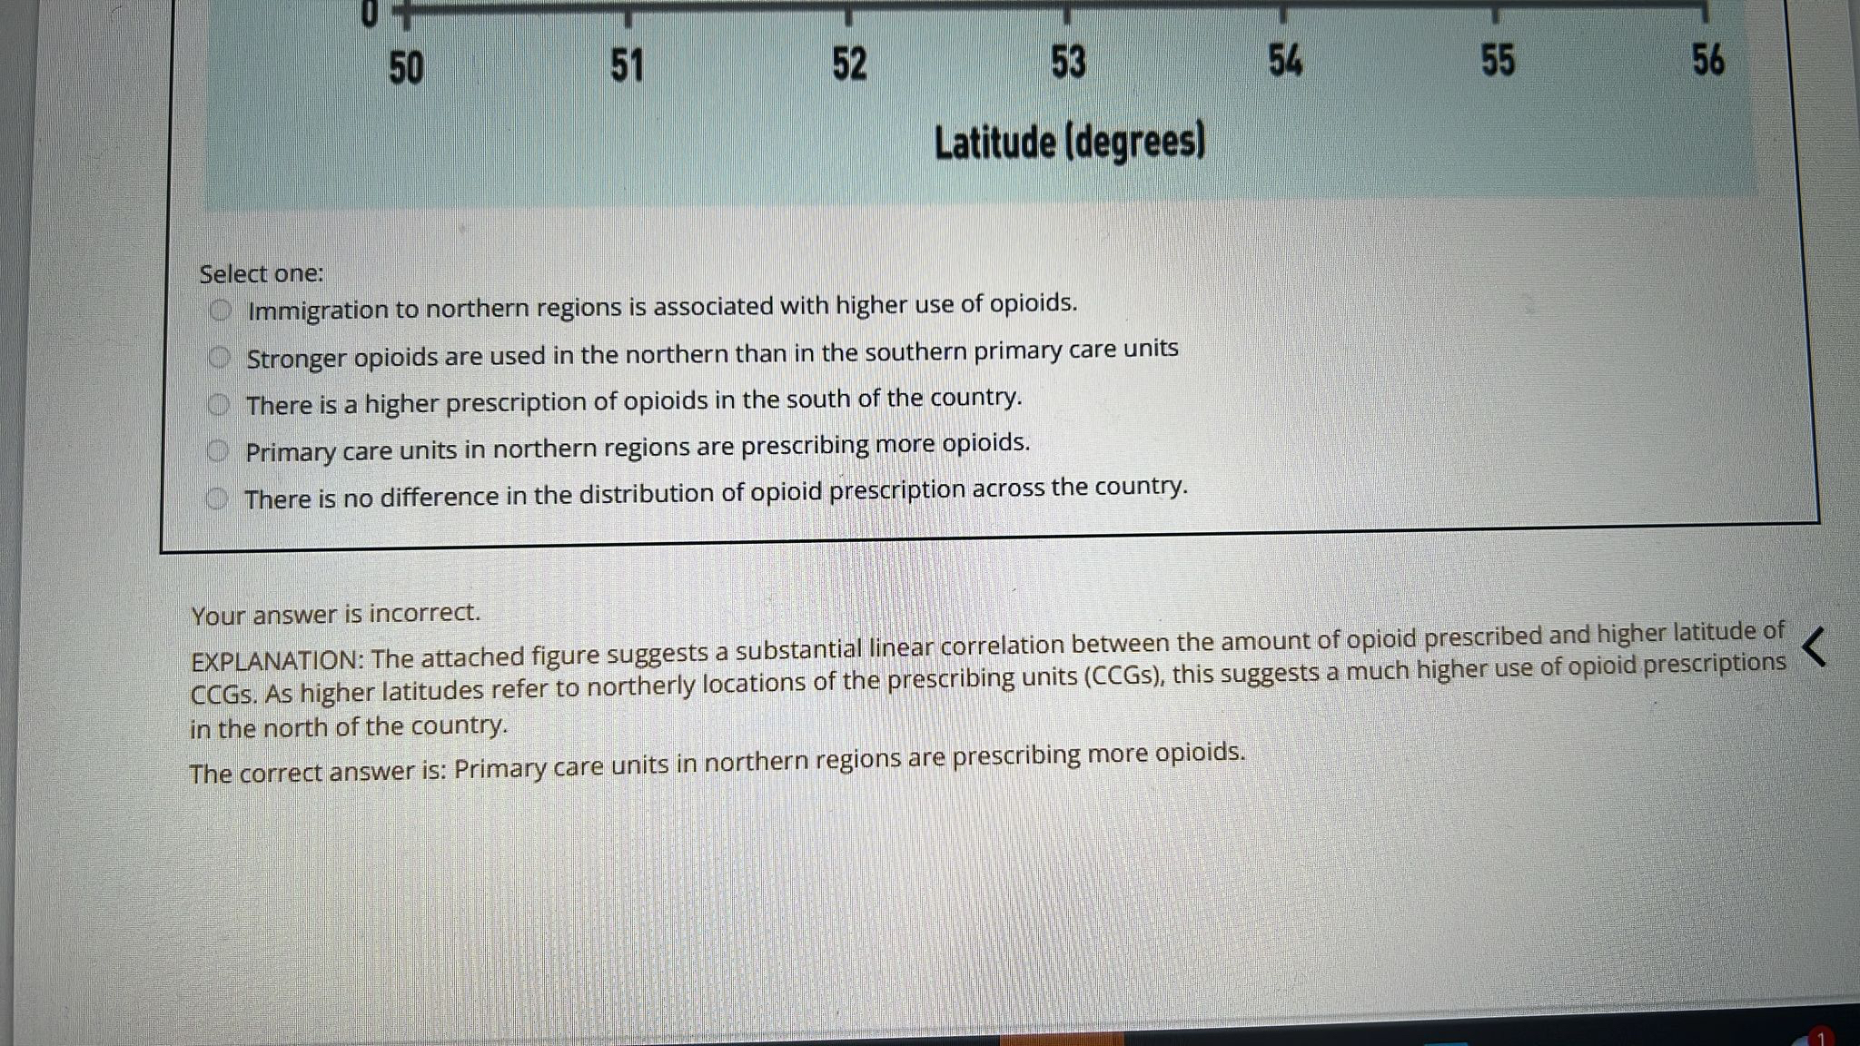
- There was one about putting participants in groups of 6 during sampling. Block randomisation
- And 1:1 was it simple randomisation?
- There was one about a computer pairing data 1:1
- I think there was something about causation or association in the question
- How about those matched with thousand in the population, was it ecological or cohort:- case control
- Schizophrenia and family table. Type of study
- 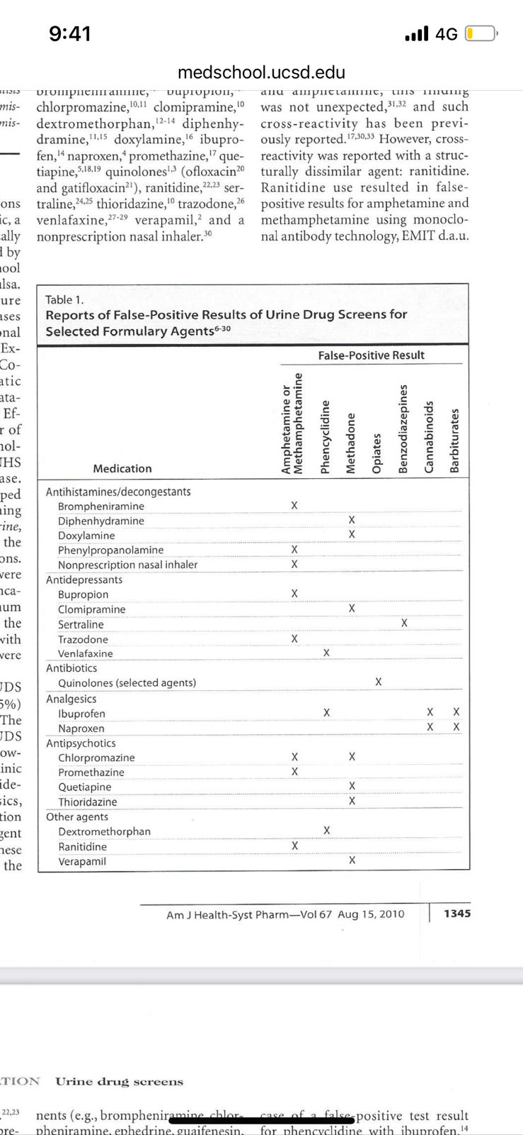
- There was a question about participants sharing subjective views of life experiences. I think this was phenomenological
- Was triangulation and grounded theory were answ in qualitative search questions
- What was the answer of preventing seclusion:- I put increase staff:patient ratio but entirely unsure. B Options were a)decorating ward b)use of benzodiazepine c)more trained staff
- There was onde where the person was considered morally or criminally responsible for something. I was torn between culpability or criminal responsibility:/ Criminal responsibility.... culpability =manslaughter
- Also what type of memory loss in ect? Explicit. There was antrograde for korsakoff too
- Guilty mind is means rea and actus rea means intention, not necessarily the same thing of moral or criminal responsibility, I think. Guilty mind and guilty act two separate things. That emi One was criminal responsibility, b Indictable offence, c Automatism
- ADHD+ tourette child (no sedation):- Guanfacine
- Liver failure alcoholic. Bzd use. No oxaz in options, I marked lorazepam
- There was one about sexual recividism, I put the one with child pornography a. Deviant plus antisocial same exact question typical on spmm
- There was a quest. Answer was chorea or hemibellismus
- Intellectual disability patient not sleeping and taking of clothes for 2 weeks
- Defence mexhanism a. Didn't call must hate me, Grand taking care of child but unconsciously resentful- reaction formation .c. jumping into conclusions - neurotic d. Husband cheats on wife and blame that wife is not faithful d. Where in therapy a pt talks about psychology but not himself
- What was method to convert qualitative into quant I marked Log transformation one
- Was any answer kendall method
- Girl preoccupied with wt bmi 24 bing and purge . A. Bulimia b. atypical anorexia nervous
- 4A's test
- Lithium with depression. What did you add on? A. Lamotrigine b. Quetiapine
- Also, Unimodal negative skew, tail on left? I kept re reading and second guessing myself.
- There was one about a patient with longstanding Alzheimer’s and recent behaviour issues, non-verbal, and asking about initial management. I put regular paracetamol because of the non-verbal thing b . urinalysis and bloods
- EMI was a q about indication for DBS....a. tourette? B. Dystonia? OCD in the options
- Was the young guy with the wing beating movement…Huntington’s? In which case was it that you’d expect the parent and grandparents to have died from same disease?Wilson's....low ceruloplasmin
- Was there a question about antidepressant to avoid in woman treating Breast cancer with tamoxifen?
- Interpersonal therapy - grief and loss

